dB Meter Test Report

Rasmus Holmalahti & Karri Korsu

Turku University of Applied Sciences

Sensors and Signal conditioning

Table of Contents

Overview 1

Objectives 1

Equipment used: 1

Third party applications: 1

Sensors: 1

Visual indicators: 2

Microcontroller: 2

Tests 3

1.  Accuracy & Calibration Test: 3

2.  Repeatability Test: 3

3.  Range & Frequency Response Test: 3

Test Environment 3

Test Methodology 3

Identified Type B Uncertainties 3

Test Results 4

General Observations 4

Sensor Validation 4

Specific Findings 4

Conclusion 4

# Overview

This report details the development and testing of a decibel meter using an ESP-12K microcontroller and KY-038 Big Sound Sensor. Designed initially to indicate decibel levels through a color-coded LED system, the project scope was expanded to incorporate an LCD display for more precise noise level readings.

The decibel meter's performance was rigorously evaluated through various tests, including accuracy and calibration, repeatability, and range and frequency response assessments. These tests were conducted in a controlled soundproof audio lab to ensure the validity of the results.

The report also delves into the identification and consideration of Type B uncertainties affecting the dB meter's accuracy, such as sensor frequency response, long-term stability, power supply variability, environmental factors, and several others. Test results indicate that the dB meter performs consistently within its optimal range of 3-6kHz, with limitations observed below 2kHz and above 7kHz.

# Objectives

• To experiment and demonstrate sensor measurements using a microcontroller

• To get familiar with GPIO connections

• Learn to program microcontrollers with C or MicroPython

• To evaluate the uncertainity in measurements, especially repeatability.

• To identify Type B uncertainities - which was measured and which was on the datasheet

• To identify Type A uncertainities

• To explore constant rate sampling (optional)

• To apply digital filters for the measured data (optional)

# Equipment used:

## Third party applications:

Frequency Sound Generator android app by LuxDeLux for noise signal generation.

## Sensors:

KY-038 Big Sound Sensor

## Visual indicators:

Red LED for severe noise, 65-90 dB

Yellow LED for moderate noise, 55-65 dB

Green LED for low noise, <55 db

LEDs had resistors for current limiting

QAPASS LCD1602 Display

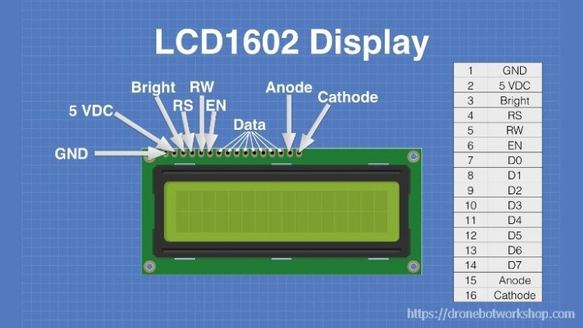

## Microcontroller:

ESP-12K

# Tests

## 1.  Accuracy & Calibration Test:

•   Compare the decibel readings from your device with a known, calibrated sound level meter. Test at various sound levels to ensure accuracy across the device's entire range.

•   Verify that the device can be correctly calibrated using a known sound source. This might involve adjusting settings or using reference equipment.

## 2.  Repeatability Test:

•   Verify that the device can measure the same signal the same way a multiple times.

## 3.  Range & Frequency Response Test:

•   Determine the effective range of sound levels that the device can accurately measure. Test the lower and upper limits of its measurement capability.

•   Check how well the device responds to different frequencies. Sound meters can have varying sensitivity to different frequency ranges.

The original plan for testing was to test 3 different signals, from 3 different distances from the sensor, with 3 different sensors. As the low frequency tests were non-compatible and performance was low even with 10 centimeters distance, tests were done with the signal generator as close as possible to the sensors.

## Test Environment

* **Location**: Soundproof Audio Lab
* **Ambient Conditions**: 21,0°C (Room Temperature)

## Test Methodology

* The dB meter was tested using sound signals generated at full volume from a smartphone speaker.
* Three different KY-038 sound sensors were used interchangeably to ensure the accuracy and reliability of the sensors themselves.
* A reference device with a different optimal frequency range was used for comparison.

# Identified Type B Uncertainties

1. **Frequency Response of the Sensor**: The dB meter's sensor may have varying sensitivity across different frequency ranges.
2. **Long-Term Stability or Drift**: Over time, the dB meter's sensor and electronic components may exhibit changes in their characteristics, affecting measurement accuracy.
3. **Power Supply Variability**: Changes in the power supply of the microcontroller or sensor can influence the readings of the dB meter.
4. **Environmental Factors**: Environmental conditions such as temperature, humidity, or air pressure can affect the accuracy of sound measurements. Our tests were done in a controlled environment safe from outside interference.
5. **Electrical Interference and Noise**: The dB meter might be susceptible to electrical noise or interference from nearby electronic devices, which can affect sensor readings.
6. **Sensor Non-linearity and Hysteresis**: The response of the sound sensor might not be perfectly linear, or it might be affected by the history of sound exposure (hysteresis).
7. **Data Acquisition System Variability**: The uncertainty related to the data acquisition system, including signal conditioning and the analog-to-digital conversion process, should be evaluated. This includes the resolution and accuracy of the microcontroller's ADC.
8. **Human Error**: Errors in setting up experiments, optimizing the algorithm, recording data, or interpreting results can introduce uncertainties.
9. **Sound Source Consistency**: Variability in the sound source used for testing (e.g., inconsistencies in sound signal generation or speaker output) can introduce uncertainty in the measurements. To battle this uncertainty, a well rated signal generator app was used for steady signal generation.
10. **Microphone Directionality**: The directional characteristics of the microphone in the sound sensor can influence readings based on its orientation relative to the sound source.
11. **Acoustic Reflections and Absorption**: The testing environment's acoustic properties, such as reflections or absorption by walls and objects, can affect sound level readings. To minimize this uncertainty tests were done in a soundproof laboratory.

# Test Results

## General Observations

* Tests focused on a frequency range from 200Hz to 10kHz.
* The dB meter showed a consistent performance in the specified optimal range (3-6kHz), with satisfactory results extending to frequencies as low as 2,5kHz.
* Measurements below 2kHz and over 7kHz indicated poor performance, leading to the conclusion that these results are non-compatible or void.
* The reference device struggled to accurately read frequencies around 5kHz, suggesting a potential blind spot or noise cancellation effect at these frequencies.

## Sensor Validation

* The use of three different KY-038 sensors confirmed that the observed performance characteristics were not due to sensor faults but are inherent to the device's design and capabilities.

## Specific Findings

* At 200Hz, the device showed readings between 50-51 dB across all sensors. Reference device showed that these measurements cannot be true.
* At 500Hz, readings varied slightly depending on the voltage (3.3V or 5.0V), with measurements ranging from 49 to 51 dB. Reference device showed that these measurements cannot be true.
* The device demonstrated its peak performance within the 3kHz to 6kHz range, accurately capturing sound levels with a maximum cap observed at 83 dB. Reference device had a maximum cap of 84,8 dB in the same circumstances.

# Conclusion

The decibel meter project successfully demonstrates the capability of the ESP-12K microcontroller and KY-038 sensor in measuring sound levels within a specific range. While the device showed consistent performance in its optimal frequency range (3-6kHz), limitations in accuracy were observed at frequencies outside this range.

The meticulous testing process, aided by the use of a controlled environment and a reference device, highlighted several inherent limitations in the meter's design and sensor capabilities. The extensive analysis of Type B uncertainties provided critical insights into factors affecting the meter's performance, underscoring the importance of considering such variables in the design and application of measurement devices.

Despite the observed limitations, the project achieved its core objectives and offers a robust platform for further exploration and refinement in sound level measurement technologies.